TITLE

Authors, Enterprise
Abstract

SUMMARY

The contents can be developed with different subsections. This document is about showing the chosen format.
- text
The main ideas, methods, calculation and design elements used must be written. Remember that the number of pages is limited.
  - Sections y sub-sections

- GRAPHICS ELEMENTS
Only figures and tables are formatted in this document..
  - Figures
The figures must be numbered with the chapter number followed by the figure number in increasing order. Its title must be centered and below the figure:

Figura 2.1. La primera figura

Remember to insert high-quality graphics and, if possible, what you want to show is well contrasted.
To place several graphs in a figure, make a table, indicating what each represents. Remember that they have to be very related to each other to group them under the same title.

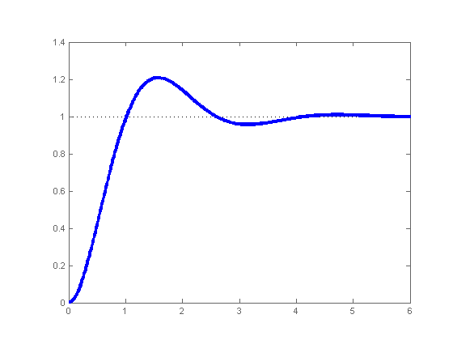 | 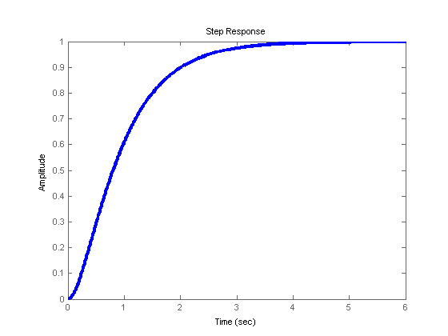
a) Subamortiguado | b) Sobreamortiguado
Figura 2.2. Respuesta ante entrada en escalón

  - Tables
The tables will also be numbered with the chapter number followed by the table number in increasing order. The title will be centered and at the top of the table.
It is recommended that the tables have concise and well-structured information. Use the following example to illustrate the format of the figures:

Table 2.1. Principales valores
Potencia | 1.2 | MW
Velocidad | 2.3 | m/s
Impedancia de línea | 0.28 | Ω

  - Equations
Equations can be inserted in the text, although with a different format than the one used here.
See the contrast of using an equation like this one: although its format can be adapted.
If you wish to reference an equation, it is recommended to number it in parentheses to the right of the equation.

$$ISE=\int_{0}^{∞}{\left(\hat{f}(τ)-f(τ)\right)⋅dτ}$$ | (2.1)

- References

[1] Benavent, X. (2001). Modelización del comportamiento dinámico de un coche real: Aplicación al simulador de conducción. PhD thesis, Institut de Robòtica. Universitat de Valencia, Polígono de la Coma, s/n.
[2] BOE93b (1993). Resolución de 29 de octubre de 1993 de la Universidad de Valencia (Estudi General), por la que se publica el plan de estudios de Licenciado en Matemáticas de esta universidad.
[3] Chrstos, J. P. and Grygier, P. A. (1997). Experimental testing of a 1994 Ford Taurus for NADSdyna validation. Technical Report SAE Paper 970563, Society of Automotive Engineers, Inc.
[4] Gavrilets, S. (1999). Dynamics of clade diversification on the morphological hypercube. Proc. R. Soc. Lond. B, 266:817-824.
[5] Gavrilets, S. (2000). Waiting time to parapatric speciation. Proc. R. Soc. Lond. B, 267:2483-2492.
[6] Hubbell, S. P. (2001). The Unifed Neutral Theory of Biodiversity and Biogeography. Princeton University Press, Princeton, NJ.
[7] Levin, S. A. (2003). Complex adaptive systems: Exploring the known, the unknown, and the unknowable. Bull. Amer. Math. Soc. (N.S.), 40(1):3-19.

